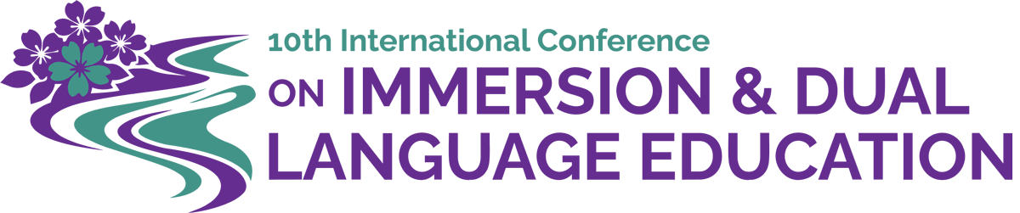
June 15, 2026

Dear [Decision-Maker Name/Title],

I am writing to advocate for the attendance of your educators and researchers at the 10th International Conference on Immersion and Dual Language (ImDL) Education, hosted by the Dual Language & Multilingual Alliance, the Southern Atlantic Language Collaborative (SALC), and the Virginia Dual Language Educators Network (VADLEN) in Reston, Virginia, near Washington, DC, from March 16 - 19, 2027.

This conference is not merely an event; it is a strategic investment in the future quality and sustained excellence of your Immersion and Dual Language programs (ImDL), and the success of your multilingual learners. The conference theme, Bridging Multilingual Worlds: From Many Voices to a Shared Future, provides an unparalleled opportunity to ensure your team remains at the forefront of the field.

Attendance is essential for your educators to:
- Secure Program Longevity: Engage in rich conversations focused on evidence-based strategies for growing and sustaining strong ImDL programs.
- Implement Best Practices: Share and acquire cutting-edge research, effective pedagogical practices, and proven classroom strategies that can be immediately implemented to benefit students in ImDL programs.
- Establish Key Collaborations: Build professional connections for advocacy and collaboration, positioning your organization to shape the future landscape of ImDL education.

This signature event delivers actionable insights directly relevant to your current priorities. The agenda features symposia and award-winning keynotes discussing critical issues that directly impact your ImDL program(s), including:
- Integration of the Science of Reading in different languages.
- Development of robust secondary pathways where students earn the Seal of Biliteracy.
- Overview of cutting-edge research, policies, and legislation from around the world.

Furthermore, the interactive Fresh Take sessions are specifically designed to facilitate problem-solving and brainstorming solutions within four organized strands, ensuring participants return with concrete, applicable plans.

Additionally, your educators may want to participate in the optional pre-conference activities, including the school site visits (March 16) and targeted pre-conference workshops (March 17), which offer valuable hands-on learning experiences and are available on a first-come, first-served basis. Here is the Conference at a Glance Schedule.

Supporting the participation of your educators, researchers, and leaders is a proactive step toward maintaining and enhancing the high quality of your ImDL programs. I encourage you to send them to this essential professional development opportunity.

With appreciation,
Conference Executive Board
DLM Alliance: Gregg Roberts-Aguirre & Amira Fahoum
SALC: Ann Marie Gunter, Ph.D. & Lisa Harris, Ed.D.
VADLEN: Beatrix Preusse-Burr & Bettina Staudt, Ed.D.

